|  |  |  |  |
| --- | --- | --- | --- |
| **Project Name** | Online Freelancing Platform | | |
| **Course-Section** | BSCS (NS) - 3AB | **Subject** | Software Engineering 1 |
| **Team Name** | Team 01 | **Driver** | Cabutaje, Mark Allen |
| **Key Contributors** | Agapor, Rachelle Ann De Guzman, Franco  Gomez, Aileen  Miñon, Alexandre Benedict Perpetua, Alyssa  Sisante, Ian | **Approver** | Rellmon P. Ponce de Leon |

**Objective**

Behind this project were the inspirational experiences of low-wage Filipino earners across the country. The project aims to help these people find a job contract easily amidst the pandemic. Since the application of the internet and technology in today's time is developing gradually, the completion of this project has become more feasible.

The developers of the project, Online Freelancing Platform, aim to create a platform where individuals can post their job expertise. This platform will serve as a form of service outsourcing for independent contractors. This project provides a link between freelancers from different fields and individuals looking for skilled workers. This website would make it easy for these people to interact. Online Freelancing Platform provides a wide range of categories, including blue-collar jobs and white-collar jobs.

To be part of the Online Freelancing Platform, begin by creating an account. Make sure that your details about yourself, expertise, skills, and work experience are all included. The admin and/or moderator will verify your identification data to decide your qualification.

**Background Information**

The country’s unemployment rate in the year 2016 – 2019 was estimated to range from 5% to 6%. According to the Philippine Statistics Authority’s labor force survey, the unemployment rate since the start of the pandemic has increased from 5% to 8.7%. The latest labor force survey was conducted last August 2021, it was reported that the unemployment rate was estimated at 8.1% equivalent to an estimated 3.88 million individuals starting from age 15 and over. A lot of people lost their businesses and jobs or simply lost their source of income ever since COVID-19 had hit us. The continuous lockdown all over the country has been one of the major reasons why people have to close down their businesses or reduce their workforce. The result of this is the increase in the unemployment rate. In order to cope up with the current situation, most of the people who have lost their jobs seek temporary work even without the help of an agency or company. Many people turn to freelancing to support the rising cost of living. The completion of this proposal will be beneficial to these people. The Online Freelance Services will serve as a platform for people who want to work more freely, for people who cannot find a permanent job position as of the moment, and for companies, organizations, and/or individuals who seek talented freelancers to accommodate their needs.

Initially, the system was planned to be a platform for freelancers and low-wage earner Filipinos or those under the category of blue-collar jobs. The features available in mind are limited to the log-in or sign-up page, location, search bar, browse page, inquiry page, and rating system.

Since there are too many missing pieces of information, there are some additional changes to the initial plan. The current insights with this project are the expanded target users, more detailed features, and web pages. For the first webpage, the admin page consists of two modes, the admin and moderator mode. On the administrator page, the sign-up/ log-in page will be required. Details like transaction logs, membership logs, and verification of members are accessible on the administrator page. The moderator page has the same functions except for the transaction logs and membership plans of members. The central function of the moderator page is to verify the new members, manage reports, and manage the activation or deactivation of the account of users. The next web page that will be available in this system is the user page. This is where the members can interact and post their works and concerns. Initially, it has a home page, sign-in page, log-in page, profile page, and newsfeed. A member can make a post about what qualifications they are looking for a potential worker or potential recruit. Once posted, the other members can see what is in it and can leave a comment to suggest their profile pages. Once the deal between the member and freelancer/s is already over, a rating system will be added as one of the many features of this project. To give them a chance to evaluate the skills of their contractors. From this instance, future clients can make this a reference in finding a suitable freelancer to do their work.

**Project Coverage**

**Scope of Work**

* The Online Freelancing Platform’s features are: (1) Login/sign that which consists of personal information, ID, indication if the account is for company use or for personal use, and skills sets wherein the users can put their certificates and such; (2) Search, anyone who are logged in into their accounts can search and see the detailed information of available freelancers and available workers. But if the user was not using any account or not logged in, the result will be limited; (3) Browse, to look for workers; (4) Post, it covers the description, quantity, tag (work), requirements, and location; (5) Inquire – chat and hire; (6) Rating/Review, the client will rate the employee/s after work; and (7) Availability -- calendar.
* Webpage(s):
  + Admin Page – The Admin page has the admin mode and moderator mode. The Admin mode has the same ability as the Moderator mode but the Admin mode have the capability to monitor the website. The Moderator mode is in charge of grunt work such as verifications – it verifies the job categories, new users, reports (Activation/Deactivation of users’ account).
  + User Page -- There is a Homepage for browsing outputs. Sign in and sign up for clients/company and freelancer/worker. In the Profile page, it has the account indicator if the user is a client or a worker. A portfolio that contains the links, pictures/video, and description. The profile also shows the report user option, create/edit/show information, ratings/review, status of availability, and availability calendar. A Newsfeed in which account users can browse available client work posts such as job description/details, requirements option (photo), and number of workers needed. The newsfeed also has a search bar, that is for searching for available works and workers/freelancers.

**Not in scope**

* The system will not handle the payment of the client to the worker

**Nice to have**

* Google Calendar - worker availability
* Google Maps - range/nearby works

**Acceptance Criteria**

This contains the initial acceptance criteria which will be the basis for the outcome of the project.

**Plans**

**Pre-conditions**

* This contains the information for any initial conditions met by the project.

**Assumptions**

* This contains the information for any assumptions towards the project.

**Code, version, and Data changes**

* This contains the information for any code or data related changes, including version if the application is already existing.

**Deployment**

* This contains the information for any deployment expected on the project.

Decisions

This contains any decisions to be made or have been made for the project.

|  |  |  |  |  |
| --- | --- | --- | --- | --- |
| **Title** | **Description** | **Impact** | **Suggestion** | **Decision** |
|  |  |  |  |  |
|  |  |  |  |  |
|  |  |  |  |  |

**Milestones, Deadlines and Timelines**

This contains the general information regarding the target milestones of the project as based on the project coverage. Based on the milestones, it will derive the projected timelines for each item which in return will provide the projected deadline of the whole project.

|  |  |  |  |  |  |  |
| --- | --- | --- | --- | --- | --- | --- |
| **Milestone** | **Start Date** | **Target End Date** | **Actual End Date** | **Status** | **Coverage** | **Test Results** |
|  |  |  |  |  |  |  |

Quality Assurance

This will provide any information related to the quality assurance of the project. It may contain test plans and validation strategies to be used on the project. For test plans, it is suggested to indicate the coverage for reference.

Checklist

Optional part of the document but nice to have. This contains any items that need to be attained for the project to become successful.

|  |  |  |  |  |
| --- | --- | --- | --- | --- |
| **Description** | **Yes** | **No** | **N/A** | **Remarks** |
|  |  |  |  |  |
|  |  |  |  |  |
|  |  |  |  |  |

**Other References, Screenshots, and diagrams**

This contains any information that will provide additional data in support of the project.

**Necessary diagrams**

* **Top-level diagram**

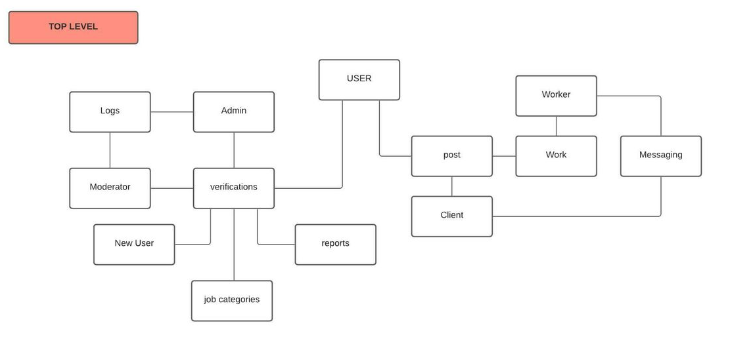

* **Low-level diagram**

**Client/Worker**

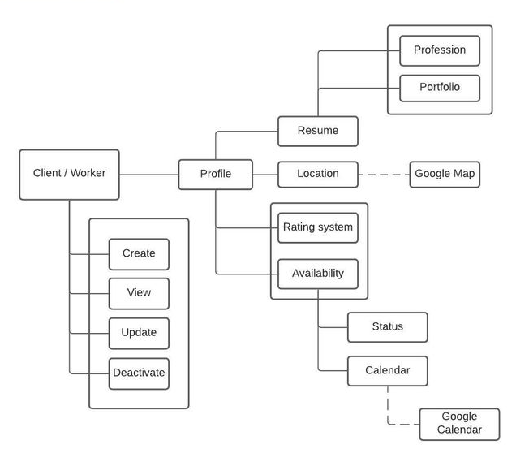

**Moderator**

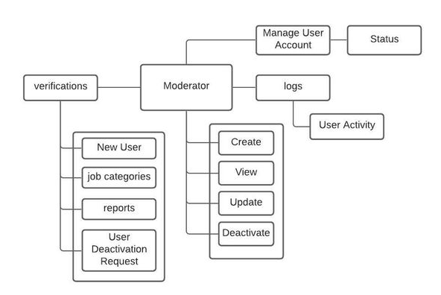

**Admin**

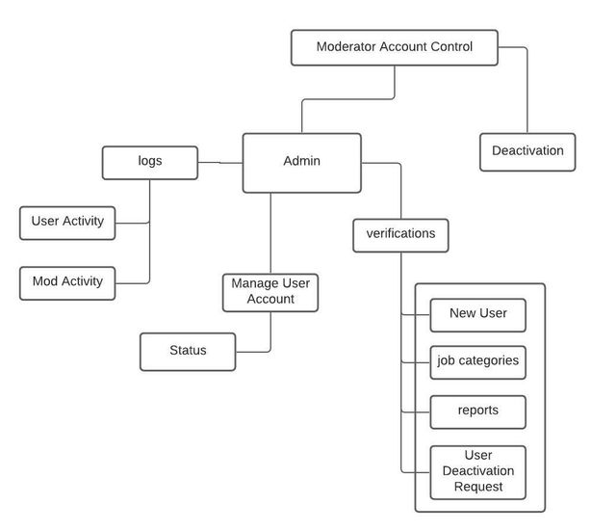

**Post**

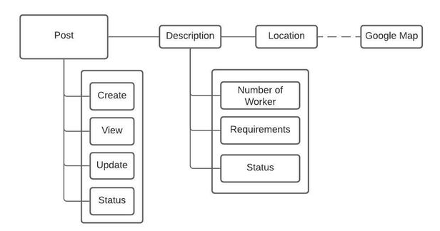

**Newsfeed**

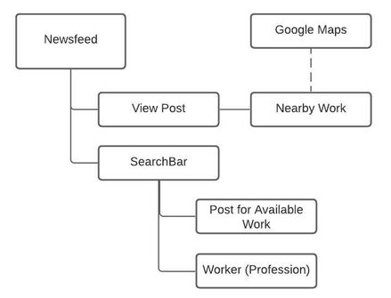

* **If applicable, network diagram**
* **Sequence diagram**
* **Data-flow Diagram**
* **Entity Relationship Diagram**

